# ACTIVITIES

EXERCICE 1:

|  |  |
| --- | --- |
| Objective | Take all the apples. |
| Maximum number of instructions | 8 |
| Allowed instructions | GO-UP GO-DOWN GO-LEFT GO-RIGHT PICK-UP REPEAT N-TIME WHILE IF |
| Allowed conditions | <HAS APPLE> |

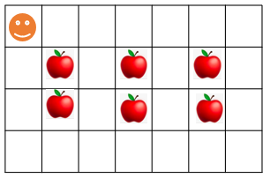

Answer:

Repeat 3-time

Go right

Repeat 2-time

Go down

Pick up

Go right

Repeat 2-time

Go up

EXERCICE 2:

|  |  |
| --- | --- |
| Objective | Bring all apples to their respective green box. |
| Maximum number of instructions | 10 |
| Allowed instructions | GO-UP GO-DOWN GO-LEFT GO-RIGHT PICK-UP DROP REPEAT N-TIME WHILE IF |
| Allowed conditions | <HAS APPLE> |

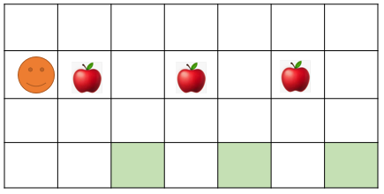

Repeat 3

Go right

Pick up

Go down

Go down

Go right

Drop

Go up

Go up

Repeat 3-time

Go right

Pic up

Go right

Repeat 2-time

Go down

Drop

Repeat 2-time

Go up

Go right

Answer:

or

EXERCICE 3:

|  |  |
| --- | --- |
| Objective | Pick up all apple and stop at the flag!! |
| Maximum number of instructions | 6 |
| Allowed instructions | GO-UP GO-DOWN GO-LEFT GO-RIGHT PICK-UP IF REPEAT N-TIME WHILE |
| Allowed conditions | <HAS APPLE> <HAS FLAG> <HAS **NO** FLAG> |

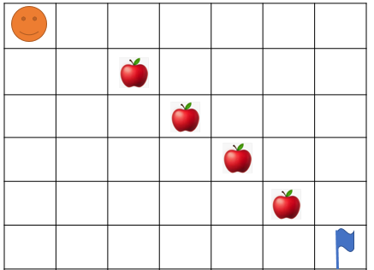

Go right

Repeat 5

Go down

Go right

If <has apple>

Pick up

Answer:

EXERCICE 4:

What happen at the end?

* How many carrots Jack eats ? 1carrot
* How many bananas Jack eats? 0banana
* Where will be Jack at the end?





















EXERCICE 5:

|  |  |
| --- | --- |
| Objective | Bring all apple to green box and stop at the flag!!  WARNING : you program must work for the 2 cases !!! |
| Maximum number of instructions | 10 |
| Allowed instructions | GO-UP GO-DOWN GO-LEFT GO-RIGHT PICK-UP DROP IF REPEAT N-TIME WHILE |
| Allowed conditions | <HAS APPLE> <HAS CELL DOWN>  <HAS FLAG> <HAS **NO** FLAG> |

Case1: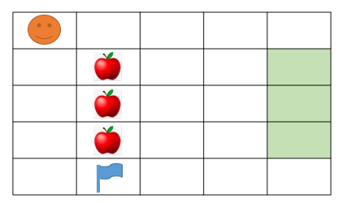

=

Case 2: 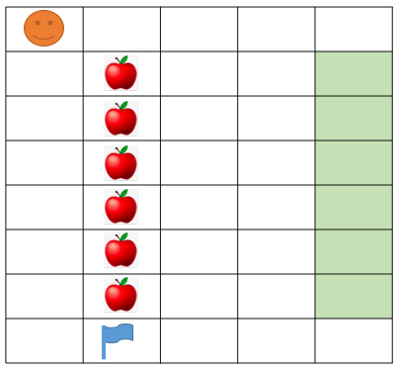





Answer:

EXERCICE 6:

|  |  |
| --- | --- |
| Objective | Take all the apple to green box  WARNING: you program must work for the 2 cases!!! |
| Maximum number of instructions | 15 |
| Allowed instructions | GO-UP GO-DOWN GO-LEFT GO-RIGHT PICK-UP DROP IF REPEAT N-TIME WHILE |
| Allowed conditions | <HAS APPLE> <HAS CELL ON RIGHT>  <HAS CELL ON LEFT> |



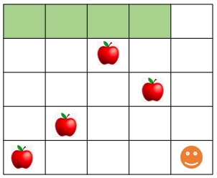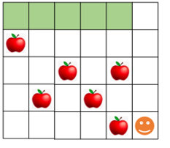



Answer:

EXERCICE 7:

|  |  |
| --- | --- |
| Objective | Take all the apple |
| Maximum number of instructions | 8 |
| Allowed instructions | GO-UP GO-DOWN GO-LEFT GO-RIGHT PICK-UP DROP  IF  REPEAT N-TIME WHILE |

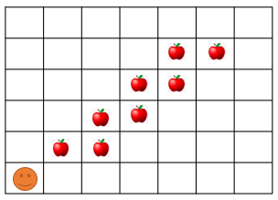

Answer:

Go right

Go up

pick up

repeat 8

go right

pick up

go up

pick up

EXERCICE 8:

|  |  |
| --- | --- |
| Objective | Take all the apple and go to the green cell |
| Maximum number of instructions | 11 |
| Allowed instructions | GO-UP GO-DOWN GO-RIGHT PICK-UP  IF  REPEAT N-TIME WHILE |

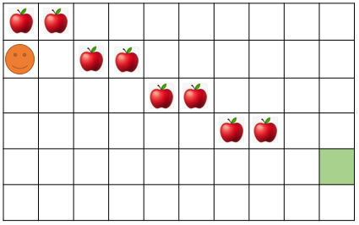

Answer: 

EXERCICE 9:

|  |  |
| --- | --- |
| Objective | Bring all apples put in the black cell and go to the green cell.  **Note**: your program must work for the 2 cases!!! |
| Maximum number of instructions | 10 |
| Allowed instructions | GO-UP GO-DOWN DROP GO-RIGHT PICK-UP  IF  REPEAT N-TIME WHILE |
| Allowed conditions | <HAS APPLE> <HAS CELL ON RIGHT>  <HAS CELL ON LEFT> <HAS CELL ON UP> |



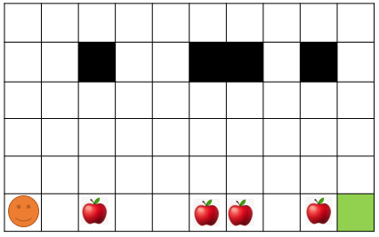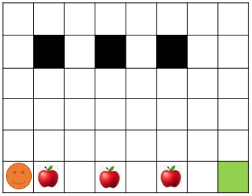

Answer: 